11/7/2017

Helena Vemba

1202227

Unit13Design a Website

Assignment 2

Table of Contents

Introduction 3

Purpose 3

Target Audience 3

Requirements 3

Main Content 4

Original/Ready-made Assets 4

Storyboard 5

Folder structure 8

9

Site Map 9

Colour Schemes 9

Hardware and Software 9

Constraints 9

Test Plan 10

Outline of alternated design ideas 10

Design decisions 11

Explanations 11

Consider the constraints 11

Conclusion 11

# Introduction

The aim of this Assignment is to improve Camp Canada also I will describe how to design a website it will be display 8 pages of Camp Canada by using features of the website.

# Purpose

The purpose of the website is aimed to attract young individuals to link into their organisation whether for leisure or employment in the great outdoors.

Camp Canada is an organisation for summer camp trips that offers unbelievable chances for young people from all around the world, the best salaries and lowest fees to the applicants, in their programme there are great opportunities you can employ that requires energy in

Camp Canada such as Support Staff, **general camp counsellor** and **activities camp counsellor which are the most popular, normally runs 9 to 10 weeks. The application can be done via online which turns the process easier and simple. The process is separated in tree basic stage, there called Application and interview, Documentation and placement and visa which the last stage once you get those processes done you will be orientated** in the UK so you know correctly what to expect when you get to Canada.

Camp Canada contains several types of camps which are:

* Traditional which is the most popular that focus on outdoor activities, water-sports, arts and crafts.
* **Underprivileged**camps provide the same activities as traditional camps.
* **Girl Guides** offer to young girls in the Girl Guide movement. Highest campers and staff will live in platform tents.
* **Wilderness** aimed to focus on outdoor activities like canoeing, hiking and camping.
* **Religious** camps deliver rage of activities that are run by Christian or Jewish organisations, the purpose is to respect and understand other people’s beliefs.
* **Physical Disability** they are concentrated to children with physical disabilities, activities are adapted to ensure the enjoyment of their experience.
* **Learning/Mental Disability and/or Developmental Delay Camps are attended** by children, camp activities are adapted to ensure the enjoyment of their experience and help them develop their talents.

# Target Audience

The audience is young individuals, students, teenagers whether if they have **physical Disability or religious also** a person who wants to work in Camp Canada. (18-24)

# 

# Requirements

These are from the assignment brief:

* At least eight linked pages.
* At least one table.
* There should be a consistent use of text, colour schemes and page styles in all of the web pages.
* The website should be interesting and have at least four suitable, different original and/or ready-mades, embedded multimedia/digital assets, e.g. digital animation, digital graphics, digital audio, digital video.
* The website should contain some interactive features, e.g. a feedback form to collect customer enquiries.
* The website should have at least two external hyperlinks to other interesting webpages.
* Each web page should be internally linked, with easy-to-navigate menus.

# Main Content

# Original/Ready-made Assets

|  |  |  |  |  |  |
| --- | --- | --- | --- | --- | --- |
| Asset No. | Asset Image | Name of asset | File Type | Source | Description |
| 1 | /Users/1202227/Desktop/index.jpg | Camp Canada Logo | .png | https://campcanada.org/ | The website logo that tells us what is the website |
| 2 | Screen%20Shot%202017-11-07%20at%2011.24.11.png | Apply Now |  | https://campcanada.org/ | When you Click into this image goes directly to the application form |
| 3 |  | Travel offer | .jpg | https://campcanada.org/ | Appealing travel offer that Camp Canada has to suggest |
| 4 |  | Applications for 2018 are officially open | .jpg | https://campcanada.org/ | Camp Canada used this photo to appeal the applicants |
| 5 |  | Life in Canada image | .jpg | https://campcanada.org/ | This picture gives us a little bit of how is Canada |

# Storyboard

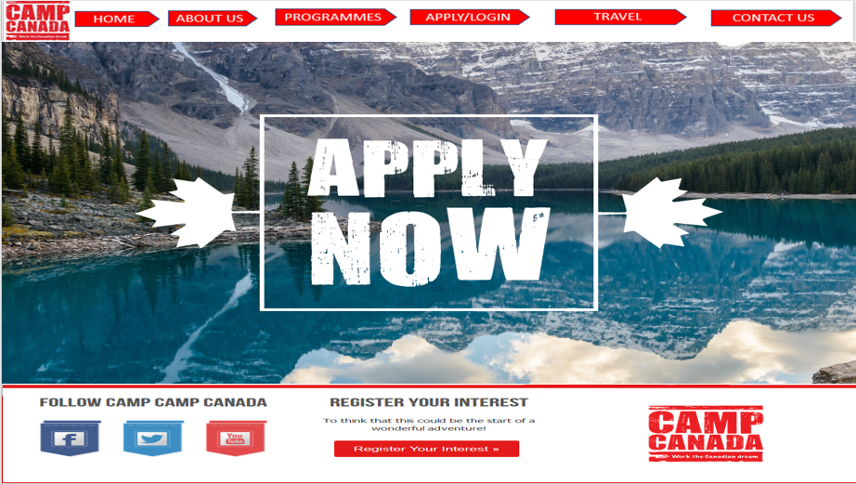The storyboard will contain 8 sketched webpages that will have information for each section such as Home page, about us, Programmes, Apply/Login, Travel and Contact us.

This is the Home page which is the main page, it will be displayed a navigation buttons, APPLY NOW that is set as hotspot that takes directly to the application form, a Register your interest set as hyperlink and it takes you to that page

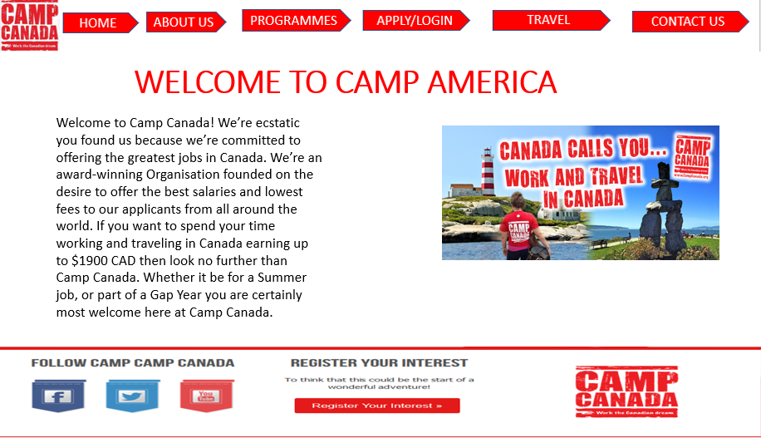

With this page visitors will know what the website about …

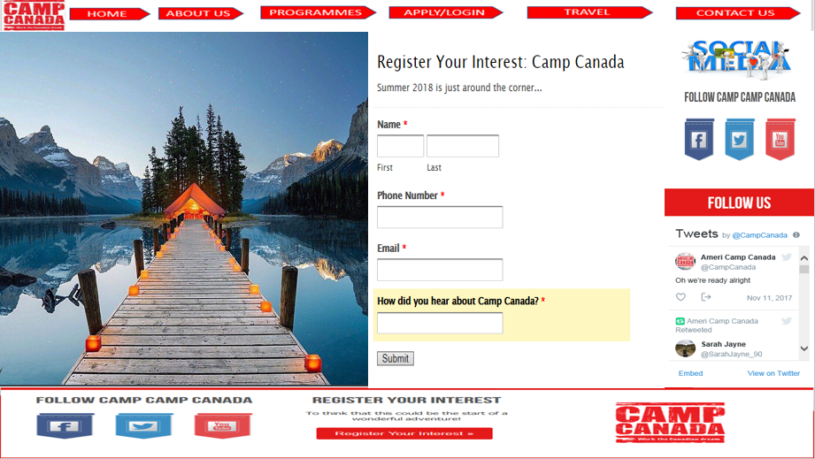 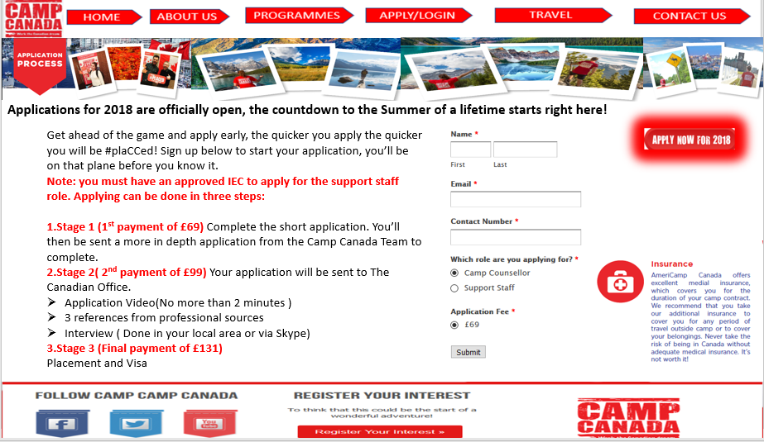

This page will be about the payment processes that need more elaboration when I design my actual website.

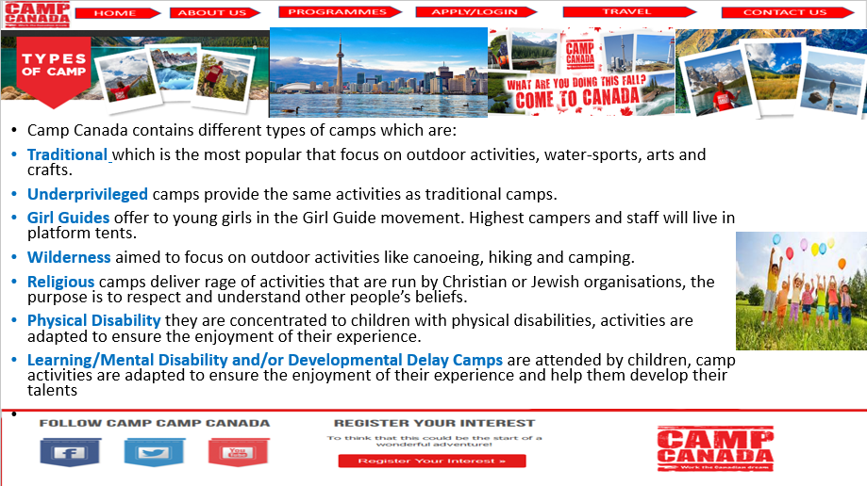

This page will display information about the types of camp and on the actual Website I will add some information about the programmes.

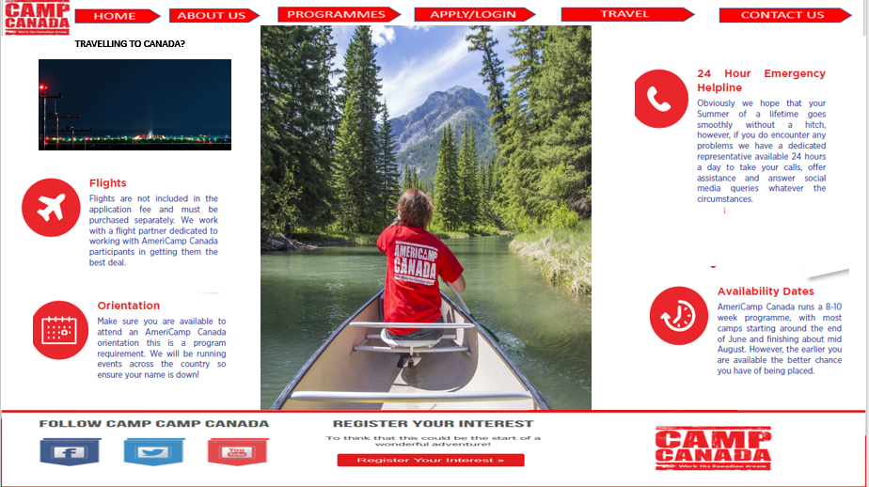

All information about the trip to Camp Canada 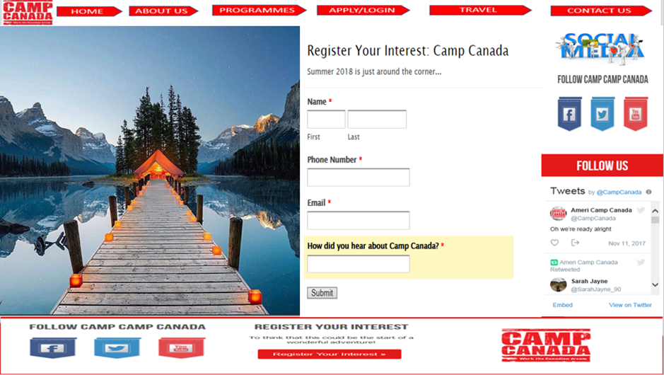 Social Media and Register your Interest

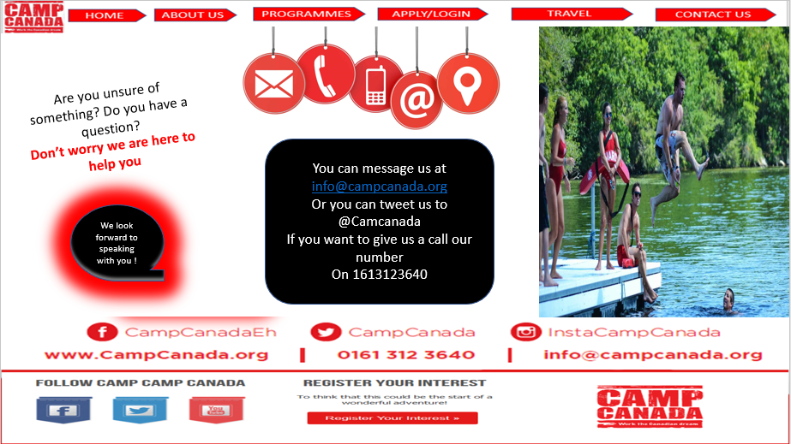

How can you get in touch with CAMP CANADA

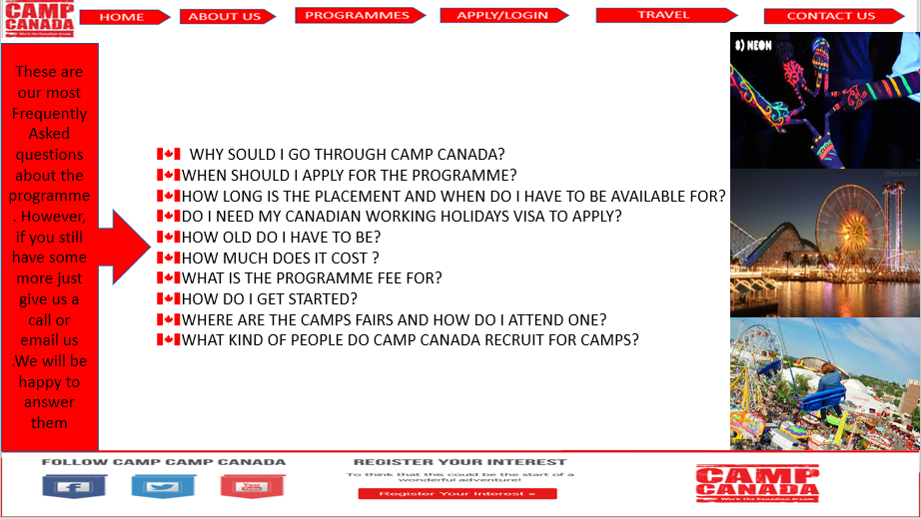

You will see the most frequent questions about the programme and other information

# 

# Folder structure

I created this folder structure to show how my pages will be linked together and its also easy to locate the relevant information

# 

# Site Map

Is it easy way to show the visitors where they can find each section of the website

HOME

ABOUT

APPLY

CONTACT

TRAVEL

PROGRAMMES

# Colour Schemes

The colour that is used to create the storyboard are white and red from the Canada flag and contrast colours such as combination like black and white that stand out , I think those colours are accessible to everyone and it is easy to read.

Font type for the tittle I used Calibri and some of text I used bold feature which is easy to read, for the font size I used 16 to 36

# Hardware and Software

To make the assignment I have been using hardware such as keyboard, monitor and mouse and for the software I used PowerPoint to create the Storyboard, Microsoft Word to complete the written part of the assignment and I will use Atom that is a text editor to create websites.

# 

# Constraints

The image below shows system information that I used to make this Assignment work.

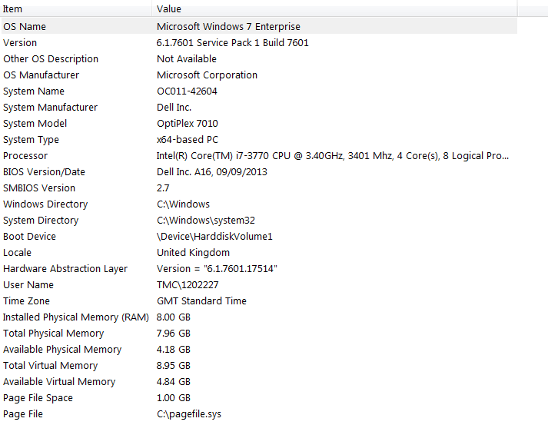

# 

# Test Plan

Name of Website: Camp Canada

Test Plan:

Name of Tester: Helena

A Test plan will be needed to test all elements of the website and ensure they work well but for instance the test plan will be in blank so that I can test when I have create the actual website I can test.

***Homepage***

|  |  |  |  |  |  |  |  |  |
| --- | --- | --- | --- | --- | --- | --- | --- | --- |
| Test No | Test | Test Data | Browser  Used | Expected Result | Actual Result | Changes Needed? | Evidence | Date |
| 1 | Test Navigation bar | Click home hyperlink | Firefox  Google Chrome | Go to home page |  |  |  |  |
| 2 | Test Navigation bar | Click about us hyperlink | Firefox  Google Chrome | Go to about page |  |  |  |  |
| 3 | Test Navigation bar | Click on programmes  hyperlink | Firefox  Google Chrome | Go to programmes section |  |  |  |  |
| 4 | Test Navigation bar | Click on Apply/Register  hyperlink | Firefox  Google Chrome | Go to directly to the application part |  |  |  |  |
| 5 | Test Navigation bar | Click on Travel  hyperlink | Firefox  Google Chrome | Go to Travel page information |  |  |  |  |
| 6 | Test Navigation bar | Click on Contact us  hyperlink | Firefox  Google Chrome | It takes the visitors to the contact part |  |  |  |  |
| 7 | APPLYNOW | Click to the image (apply now) | Firefox  Google Chrome | Opens the application form |  |  |  |  |

**About**

|  |  |  |  |  |  |  |  |  |  |
| --- | --- | --- | --- | --- | --- | --- | --- | --- | --- |
| Test No. | Test | Test Data | Browser used | Expected  Result | Actual  Result | Changes  Result | Changes  Needed? | Evidence | Date |
| 1 |  |  | Firefox  Google Chrome |  |  |  |  |  |  |
| 1 | **Hot spot image** | **Click into image** | Firefox  Google Chrome | **Refresh the page and go directly to application form** |  |  |  |  |  |

**Programmes**

|  |  |  |  |  |  |  |  |  |  |
| --- | --- | --- | --- | --- | --- | --- | --- | --- | --- |
| Test No. | Test | Test Data | Browser used | Expected  Result | Actual  Result | Changes  Result | Changes  Needed? | Evidence | Date |
| 1 | **navegation** | **Click in traditional camps** | **Firefox**  **Google Chrome** | **Shows images related to that type of camp** |  |  |  |  |  |
| 2 | **Navigation tool** | **Click in Underprivileged camps** | **Firefox**  **Google Chrome** | **Shows images related to that type of camp** |  |  |  |  |  |
| 3 | **Navigation tool** | **Click in Girl Guides camps** | **Firefox**  **Google Chrome** | **Shows images related to that type of camp** |  |  |  |  |  |
| 4 | **Navigation tool** | **Click in Wilderness camps** | **Firefox**  **Google Chrome** | **Shows images related to that type of camp** |  |  |  |  |  |
| 5 | **Navigation tool** | **Click in Religious camps** | **Firefox**  **Google Chrome** | **Shows images related to that type of camp** |  |  |  |  |  |
| 6 | **Navigation tool** | **Click Physical Disability** | **Firefox**  **Google Chrome** |  |  |  |  |  |  |
|  | **Navigation tool** | **Click Learning/Mental Disability and/or Developmental Delay Camps** | **Firefox**  **Google Chrome** |  |  |  |  |  |  |
|  |  |  |  |  |  |  |  |  |  |

**Apply**

|  |  |  |  |  |  |  |  |  |  |
| --- | --- | --- | --- | --- | --- | --- | --- | --- | --- |
| Test No. | Test | Test Data | Browser used | Expected  Result | Actual  Result | Changes  Result | Changes  Needed? | Evidence | Date |
| 1 | **Submit button** | **click** | **Google**  **Chrome**  **explorer** | **Marquee saying thank you for your application , we will answer shortly** |  |  |  |  |  |
|  |  |  |  |  |  |  |  |  |  |
|  |  |  |  |  |  |  |  |  |  |

**Travel**

|  |  |  |  |  |  |  |  |  |  |
| --- | --- | --- | --- | --- | --- | --- | --- | --- | --- |
| Test No. | Test | Test Data | Browser used | Expected  Result | Actual  Result | Changes  Result | Changes  Needed? | Evidence | Date |
| 1 | **Gif image** | **Don’t need to press anything** | **Firefox**  **Google chrome** | **Have to be in moviment** |  |  |  |  |  |
| 2 |  |  |  |  |  |  |  |  |  |
|  |  |  |  |  |  |  |  |  |  |
|  |  |  |  |  |  |  |  |  |  |
|  |  |  |  |  |  |  |  |  |  |
|  |  |  |  |  |  |  |  |  |  |
|  |  |  |  |  |  |  |  |  |  |

**Contact us**

|  |  |  |  |  |  |  |  |  |  |
| --- | --- | --- | --- | --- | --- | --- | --- | --- | --- |
| Test No. | Test | Test Data | Browser used | Expected  Result | Actual  Result | Changes  Result | Changes  Needed? | Evidence | Date |
| 1 | **Animation image** | **Have to in moviment** | **Firefox**  **Google chrome** | **Have to in moviment** |  |  |  |  |  |

# Outline of alternated design ideas

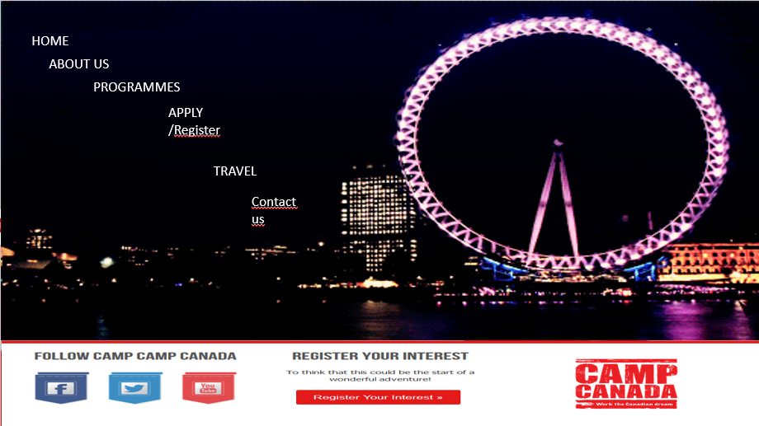

I decided to follow my first design because this one just looks confused; the visitors will distract them by the effects that the home page can cause and even the navegation bar are not placed as right , there is no logo of Camp Canada which makes worst because guest will not know what is the website until they search

# Conclusion

In my opinion my first design is attractive and stands out make the reader search for more information or even to apply to their programme, I decided to use Black, white colours and red because it can be accessible for anyone that visit the website .I need to make sure that all the content is effective for the target audience and make sure that every page contains what the target audience expect to contain,

Atom is an open source does not cost anything and improves performance but if you write something wrong into atom your code will not work as supposed to and with this assignment I realised some key features and factors to create a design which is not easy because you have to think everything in detail I enjoyed making the storyboard.